Commentary >> Third Party Commentary >> Symposium Papers (CPA Canada Commodity Tax) >> 2011 (Calgary, February 28 - March 1) >> 6. Update on Customs and Trade

UPDATE ON CUSTOMS AND TRADE
By: Lisa Zajko, Deloitte & Touche LLP

Agenda
• Department of Finance Tariff Relief Initiatives
• Other Legislation and Policy Updates
• Valuation Program
• CBSA Audit Priorities
• Recent Cases
• AMPS Update
• Incoterms 2010 – What has changed?
• Trade and Security
• Export Controls
• International Trade – Negotiations and Agreements

Department of Finance Tariff Relief Initiatives
Economic Action Plan
• Budget 2009: Tariffs eliminated on a wide range of machinery and equipment, resulting in estimated duty savings approximating $440M over five years
• Budget 2010: Additional tariffs eliminated on machinery and equipment as well as manufacturing inputs, affecting more than 1500 tariff items and resulting in approximately $250-$300M in annual duty savings
• Canada Gazette, Part I (Feb. 5, 2011) - Request for submissions by March 7, 2011 in respect of proposed additional relief; the list of items affected can be found at: http://canadagazette.gc.ca/rp-pr/p1/2011/2011-02-05/html/notice-avis-eng.htm#d105
– Relief may be phased, but is not to extend past January 1, 2015
Other:
• Additional submissions for trailers behind certain motorcycles by March 17,2011
• Ferry boats, Tankers, and Cargo Vessels Remission Order, 2010

Other Legislation and Policy Updates
• Re-assessment Policy, Reason to Believe, Voluntary Disclosures
• NAFTA Rules of Origin - Track IV Changes
• B2 Processing
– CN 10-005: ON and QC processing B2s effective April 1, 2010
– Exceptions; B2s from verifications, blanket B2s, and recourse
• CFIA - Proposed licensing regime for imports of certain food products and ingredients
• Importation of Goods Contaminated with Soil
• Delays on co-ordination with GST colleagues on proposed relief to be provided
• Wash transaction policy is not a "dead" issue - still alive; GST concerns as person who paid Div III tax is not necessarily the one entitled to the ITC.

Valuation Program
• Sale for Export and Purchaser in Canada - Cherry Stix
– First decision (2007);
• Non-resident (Cherry Stix) had prior agreement to sell to a resident (Wal-Mart); value could not be based on price from manufacturer
– Second decision (2010);
• Relevant sale for export is based on sale whereby title passes to the importer (re Mattel)
• Importer is the party who holds title to the goods at time of import
• Title did not transfer to Wal-Mart until after import - no sale for export
• TV method not applicable
• Determine value under an alternative method
• Could result in refunds and/or lower value under deductive value method
– VPU looking to "fix" the confusion caused by the decision and is treating it is a "one-off"
• July 2009 - CBSA issues a policy on "subsequent proceeds" or "post-importation payments and fees"; aimed squarely at related parties
– General presumption
– Requirements for administrative exclusion
– Experience in recent verifications
• Initiatives by VPU (HQ)
• Downward transfer pricing adjustments
• Updates to 8 or 9 D-Memorandum around April but nothing substantive
• Clarification on "clear and evident" legislative provisions
– Proposed items: PPP, packing costs and charges, "assists", and transportation

CBSA Audit Priorities (2010/11)
• Tariff classification
– Furniture parts; organic surface-active agents, soap, and other than soap; copper and articles thereof; stone vs. articles of stone; tools, implements, cutlery, spoons, and forks of base metal, and parts; juice products; textile bags; racing shells
• Origin verification
– Mattress upholstery, electric generators, pumps for liquids
• Valuation
– Light-duty automotive goods; ski apparel; parts of gas turbines; bulk ore; plastic household goods; motor car, bus, and lorry tires; video recording apparatus; pumps for liquids, articles of jewelry and parts thereof, of precious metal or of metal clad with precious metal

Recent Cases
• Cherry Stix Ltd, (per above)
• SIMA: Aluminum Extrusions and Maax Bath Inc.
• C.B. Powell Limited-Tariff Classification and NAFTA
• Wolseley Engineered Pipe Group - Tariff Classification and NAFTA
• Jockey Canada Company Limited - Judicial Review: Reason to Betieve

AMPS Update
• CBSA has released updated national statistics (July 2007 to June 2010)
– 91.49% issued at Level 1; 4.46% at Level 2; 4.02% at Level 3
– Level 3 penalties account for 24.61% of total value of penalties
• Customs Notice 10-002 (February 26,2010)
• Total assessments by client type:
 | Importers | % | Carriers | % | Whse Operators | % | Total
#PA | 17,757 | 74.58 | 4,669 | 19.74 | 1,354 | 5.69 | 23,810
V | 54,979 | 85.56 | 6,995 | 10.89 | 2,282 | 3.55 | 64,256
P | 14,473,111 | 57.69 | 7,407,071 | 29.52 | 3,209,608 | 12.79 | 25,089791
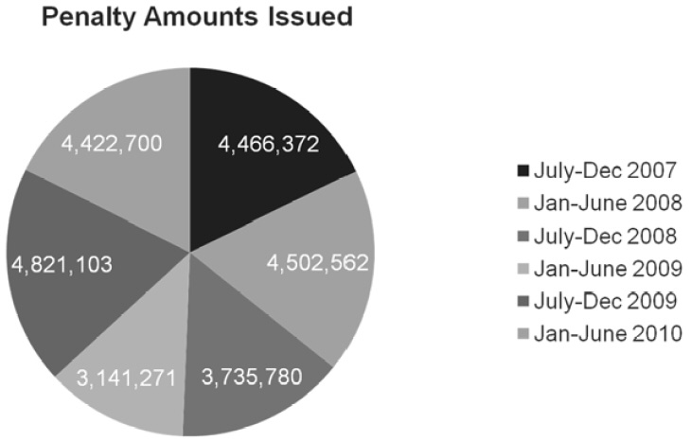
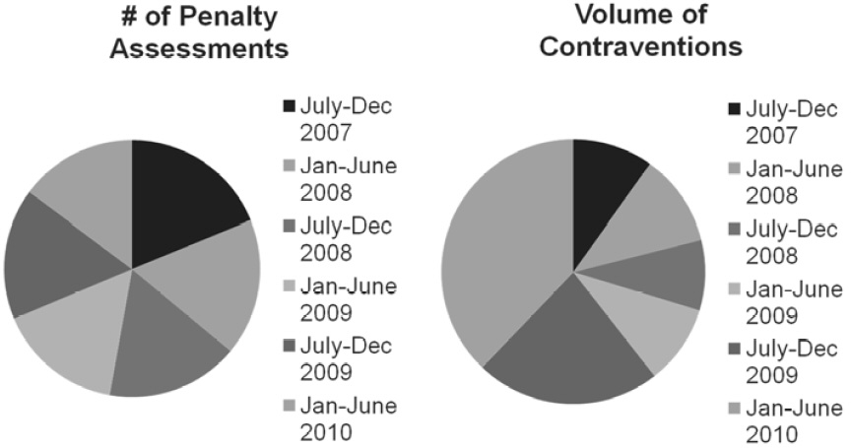
• Top 10 contraventions:
– C083 and C353 - Fail to correct value for duty within 90 days
– C082 and C352 - Fail to correct tariff classification within 90 days
– C336 - Fail to pay duties on goods that have been accounted for
– COOS - Provide information that is not true, accurate, or complete
– C084-C151 - Marking contraventions
– C021 - Carrier failed to report imported goods
– C358 - Removal of goods from a customs office or sufferance warehouse prior to release or authorization
– C018 - Commercial carrier failed to report passengers or crew
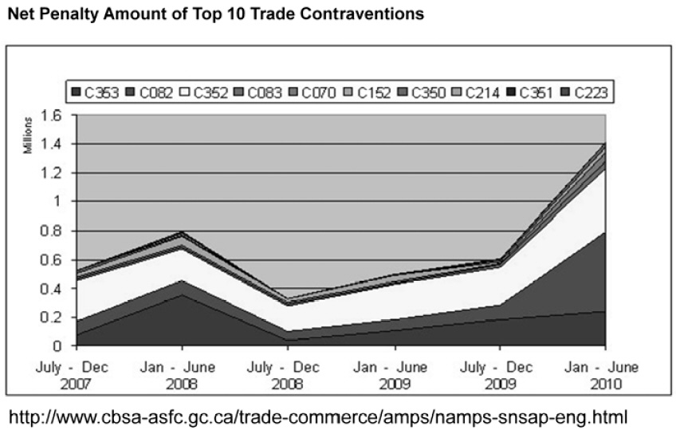
• Significant increase of value of trade penalties in Jan-June 2010
– C082 - $550,800 (up from $99,900 in prior 6 months)
– C352 - $434,575 (up from $268,683 in prior 6 months)
– C353 - $239,841 (up from $181,322 in prior 6 months)
• Only 8% of AMPS were appealed, and appeals have been declining
• Of those appealed, 68.31% were upheld, 29.67% were cancelled and 1.91% were administratively closed

Incoterms 2010 - What has Changed?
Incoterms 2000 | Incoterms 2010
4 categories | 2 categories
13 terms | 11 terms
DAF, DES, and DDU | DAP - Delivery is achieved once the goods are placed at the disposal of the buyer on the arriving means of transport ready for unloading
DEQ | DAT - Delivery is achieved when the goods, once unloaded from the arriving means of transport, are placed at the disposal of the buyer at a named terminal at the named port or place of destination
FOB, CFRP GIF - risks passes from seller to buyer when goods cross the ship's rail | FOB, CFR, GIF - risk passes from seller to buyer when goods have been loaded on board
Argentina, Japan and Turkey have been preventing certain goods from being imported because the documents showed DDU (not valid under 2010 rules). International Chamber of Commerce has asked the WCO to communicate on an urgent basis that companies are not required to use the new version and the old rules are available to use should the parties agree.

Trade and Security
• Declaration on a Shared Vision for Perimeter Security and Economic Competitiveness:
– Focus Areas:
• Addressing threats early
• Trade facilitation, economic growth, and jobs
• Integrated cross-norder law enforcement
• Critical infrastructure and cyber-security
– Beyond the Border Working Group
– US-Canada Regulatory Co-operation Council
– Second Report to Leaders on the Clean Energy Dialogue (CED)
• eManifest update

Export Controls
• Special Economic Measures (Iran) Regulations
• Export Permits for Cryptographic Items (EU+5)
• DFAIT Briefing on February 3, 2011:
– New features added to EXCOL
• Online reporting of single shipment permits, a choice of permit validity period, and a drop-down menu to select types of cryptography permits
– New export controls handbook
– Changes to ECL will be released in April
• Add new controls for certain CCD image sensors and para-military surface vehicles
• Carbon fibre and ancillary encryption (for gaming or household appliances) will be decontrolled
– Ease burden on some dual use and cryptographic goods
• Multiple destination permits; new GEPs (regulatory consultations in June 2011)
• Export controls in Malaysia

International Trade - Negotiations and Agreements
Agreements Signed in 2010:
• Canada-Panama Free Trade Agreement, signed May 14, 2010
Current Negotiations Include:
• European Union
• Turkey, Ukraine
• Morocco
• Japan
• India
• Honduras
Other Agreements
• US Request for Arbitration under Softwood Lumber Agreement
• Canada-US Agreement on Government Procurement (Feb. 16, 2010)

View Terms and Conditions and Privacy Policy
Help desk: Mon-Fri, 9am-5pm ET 1-866-256-6842 Contact Us
© 2001-2024, EYEP and/or E&Y LLP and/or CPA Canada. All rights reserved.

